Design Project Proposal

The names of all the group members (and optionally a group name)

1. Khoa
2. Alex
3. Khaled

Group name: AKK

Program name or title

Pinball - Fun games

Program objectives and description

Create a fun pinball game to make it feel like you‘re in an arcade. We want to include as many details as possible to make it look realistic and make it appealing to almost any age group and especially easy to access from anywhere. We’ll have a specific theme for our pinball machine: Star Wars.

A timeline with 4 or more “milestone” dates to ensure the project is completed on time. (reserve time for testing!)

1. GUI – 29.7.23
2. Visual – 30.7.23
3. Physical movement – 31.7.23
4. Audio – 31.7.23
5. /
6. /
7. /

List of all members in the group and what each person is responsible for.

1. Khoa: Graphic/visual
2. Khaled: Physical movement
3. Alex: Audio, GUI, background, design project proposal

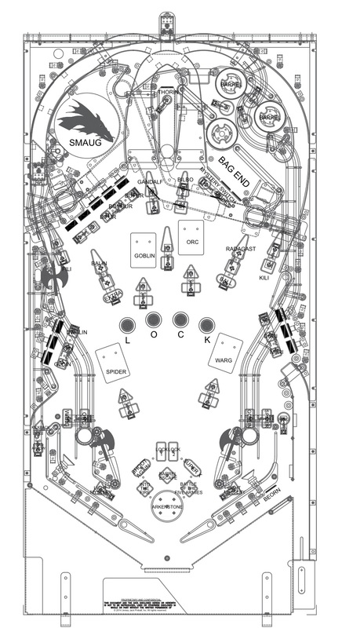Visuals or diagrams if appropriate. (use the back of this paper if needed)

Something similar to this

Theme for the background: Star Wars